SIMATS ENGINEERING
ASSESSMENT TOOL 2: Scenario-Based Research Assessment

COURSE NAME: | ARTIFICIAL INTELLIGENCE  AND EXPERT SYSTEMS | COURSE CODE: | MLA0101
COURSE OUTCOME COVERED
CO1: Apply search algorithms and heuristic techniques to solve state-space search and optimization problems. (BTL 3)
Assessment Tool Weightage: 45 %
Total Marks: 50 Time: 60 Mins
No. of Questions: 5
Annexure A
Scenario-Based Research Assessment
Code of Conduct:

I __K. Teja Sri (192525249) (Name / Reg No) certify that this submission is my original work and that I have adhered to the guidelines specified for this assessment. I understand that any violation of academic integrity rules will result in disciplinary action.


Signature of the student:

Criterion | Weightage | Marks Obtained
Identification of Latest AI Application | 10%
Problem Analysis and Domain Understanding | 15%
AI Technologies and Working Mechanism | 20%
Research Quality and Literature Review | 10%
Real-World Implementation and Case Analysis | 10%
Impact, Challenges, and Future Scope | 15%
Originality and Critical Thinking | 10%
Organization, Presentation, and Documentation | 10%
Total | 100%

Signature of the Faculty Total Marks Awarded

ANSWER ANY ONE

No. | AI Domain | Scenario-Based Research Question
1 | Healthcare | Healthcare organizations are increasingly adopting Artificial Intelligence to improve diagnosis, treatment, and patient monitoring. Identify and research a latest AI-based application in healthcare (such as AI-assisted medical diagnosis, AI radiology systems, robotic surgery, AI drug discovery, or virtual healthcare assistants). Analyze its working principles, AI techniques used, real-world implementation, benefits, and limitations.
2 | Finance | Financial institutions are leveraging Artificial Intelligence to enhance security, decision-making, and customer services. Identify and research a latest AI application in the finance domain (such as AI fraud detection systems, AI-powered financial advisors, algorithmic trading platforms, or intelligent banking assistants). Discuss its functionality, technologies involved, advantages, and challenges.
3 | Retail | Retail companies are adopting AI-driven solutions to provide personalized and intelligent shopping experiences. Identify and research a latest AI application in retail (such as Generative AI shopping assistants, AI recommendation engines, virtual try-on systems, or AI-based demand forecasting). Explain its application, AI methods used, impact on customers and businesses, and future scope.
4 | Autonomous Vehicles | The transportation sector is rapidly evolving with AI-based autonomous systems. Identify and research a latest AI application in autonomous vehicles (such as self-driving technology, AI-based perception systems, autonomous delivery vehicles, or intelligent traffic management). Analyze the AI technologies involved, real-world deployment, benefits, and challenges.
5 | Robotics | Intelligent robots are being developed for applications in industries, healthcare, education, and daily life. Identify and research a latest AI application in robotics (such as humanoid robots, collaborative robots, service robots, or AI-powered warehouse robots). Explain their capabilities, AI techniques, real-world usage, and future developments.
6 | Manufacturing | Manufacturing industries are integrating AI to achieve smart and automated production environments. Identify and research a latest AI application in smart manufacturing (such as AI-based predictive maintenance, computer vision quality inspection, digital twins, or autonomous manufacturing systems). Discuss its working, industrial applications, advantages, and limitations.

Structure of the Report:

S.No | Report Component | Student Deliverable / Guiding Question
1 | Title of AI Application | Provide the name of the latest AI application selected and the corresponding AI domain.
2 | Domain Selection | Identify the application domain (Healthcare / Finance / Retail / Autonomous Vehicles / Robotics / Manufacturing).
3 | Introduction and Background | Describe the AI application and provide an overview of its purpose and importance.
4 | Problem Identification | Explain the real-world problem or challenge addressed by this AI application.
5 | Need for AI Solution | Analyze why AI is required and how it improves traditional approaches.
6 | AI Technologies Used | Identify the AI techniques involved (Machine Learning, Deep Learning, NLP, Computer Vision, Generative AI, Robotics, etc.).
7 | Working Mechanism | Explain how the AI system works, including input data, processing methods, decision-making, and output generation.
8 | Data Sources and Processing | Describe the type of data used and how the data is processed for intelligent decision-making.
9 | Real-World Implementation | Identify organizations, industries, or real-world scenarios where this AI application is currently implemented.
10 | Impact and Benefits | Evaluate the improvements achieved through the AI application in terms of efficiency, accuracy, cost, user experience, or automation.
11 | Challenges and Limitations | Discuss technical, ethical, privacy, security, and deployment challenges associated with the application.
12 | Future Scope and Emerging Trends | Explain possible enhancements, future developments, and research opportunities in this AI application.
13 | Conclusion | Summarize the significance of the AI application and its contribution to solving real-world problems.
14 | References | Provide research papers, technical articles, industry reports, and reliable sources referred for the study.

MLA0101-Artificial Intelligence and Expert Systems
CO1-Assessesment Tool2
Scenario Based Research Assessment

Name: K. Teja Sri
Register No:192525249

Artificial Intelligence in Healthcare: AI-Assisted Medical Diagnosis Using Med-Gemini

1. Title of AI Application
AI-Assisted Medical Diagnosis Using Med-Gemini
Domain: Healthcare

2. Domain Selection
The selected domain is Healthcare. Artificial Intelligence is transforming healthcare by improving disease diagnosis, supporting doctors in clinical decision-making, reducing medical errors, and enhancing patient care. Med-Gemini is one of the latest AI applications designed to understand medical text, images, and patient records for accurate diagnosis.

3. Introduction and Background
Artificial Intelligence is revolutionizing modern healthcare by assisting medical professionals in diagnosing diseases quickly and accurately. Med-Gemini is an advanced multimodal AI model developed to analyze medical images, laboratory reports, patient history, and clinical notes. It supports doctors by providing intelligent suggestions and reducing diagnosis time. This technology improves healthcare quality while ensuring better patient outcomes.

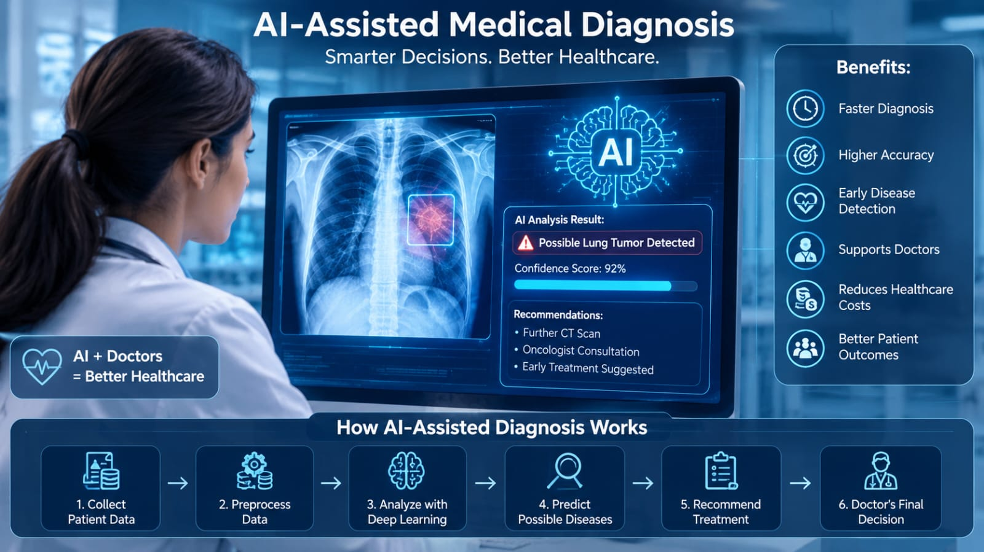

4. Problem Identification
Healthcare professionals often face challenges such as:
- Large numbers of patients.
- Complex medical records.
- Delayed diagnosis.
- Human errors.
- Limited specialist availability in rural areas.
These challenges can delay treatment and reduce healthcare quality.

5. Need for AI Solution
AI is required because it:
- Processes huge medical datasets rapidly.
- Detects diseases with high accuracy.
- Supports doctors in decision-making.
- Reduces diagnostic errors.
- Saves time and healthcare costs.
- Provides healthcare assistance even in remote areas.
Compared to traditional diagnosis, AI delivers faster and more consistent results.

6. AI Technologies Used
The system uses:
- Machine Learning (ML)
- Deep Learning (DL)
- Computer Vision
- Natural Language Processing (NLP)
- Generative AI
- Large Language Models (LLMs)
- Medical Image Analysis
- Neural Networks
These technologies enable the system to understand medical reports, X-rays, MRI scans, CT scans, and patient history.

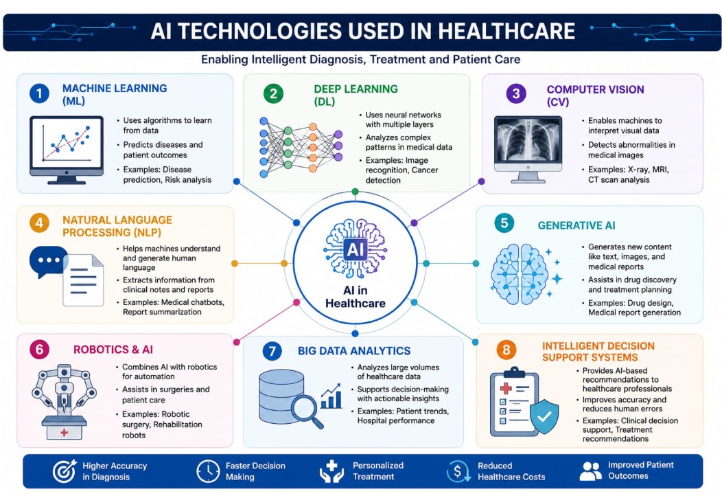

7. Working Mechanism

Step 1: Collect patient information, symptoms, medical history, laboratory reports, and medical images.
Step 2: Preprocess the data by removing noise and standardizing the information.
Step 3: Deep learning algorithms analyze medical images while NLP processes clinical text.
Step 4: AI compares the information with millions of medical records and trained models.
Step 5: The system predicts possible diseases and recommends suitable treatments.
Step 6: Doctors review the AI recommendations and make the final clinical decision.
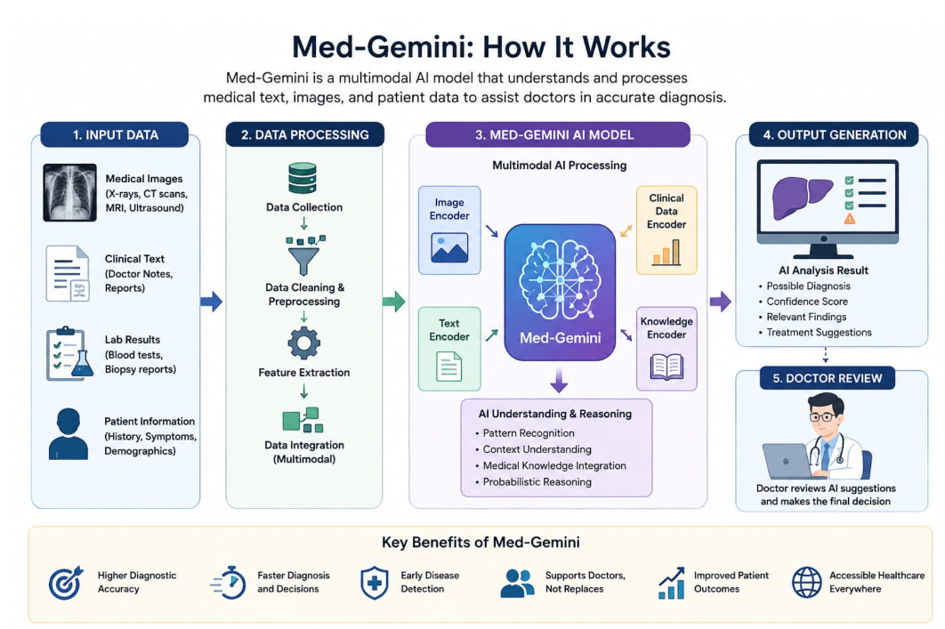

8. Data Sources and Processing
The AI system uses:
- Electronic Health Records (EHR)
- X-ray images
- MRI scans
- CT scans
- Blood test reports
- Clinical notes
- Medical research databases
The collected data is cleaned, normalized, labeled, and processed using machine learning models before prediction.

9. Real-World Implementation
AI-assisted diagnosis is currently used by:
- Google DeepMind
- Mayo Clinic
- Cleveland Clinic
- Apollo Hospitals
- NHS (United Kingdom)
Applications include:
- Cancer detection
- Diabetic retinopathy diagnosis
- Brain tumour detection
- Heart disease prediction
- Lung disease analysis

10. Impact and Benefits
Benefits include:
- Faster diagnosis
- Higher accuracy
- Early disease detection
- Reduced healthcare costs
- Better patient monitoring
- Reduced workload for doctors
- Improved healthcare accessibility
- Better patient satisfaction

11. Challenges and Limitations
Challenges include:
- Patient data privacy
- Cybersecurity risks
- High implementation cost
- Requirement for quality medical datasets
- Ethical concerns
- AI bias
- Need for human supervision
- Regulatory compliance

12. Future Scope and Emerging Trends
Future developments include:
- Personalized AI treatment plans.
- Wearable AI health monitoring.
- AI-assisted robotic surgery.
- Digital twins for patients.
- Remote healthcare through AI.
- Improved multimodal AI systems.
- Faster disease prediction with advanced deep learning.
AI is expected to become an essential assistant for doctors rather than replacing them.

13. Conclusion
Artificial Intelligence is transforming healthcare by improving diagnosis, treatment planning, and patient care. Med-Gemini demonstrates how advanced AI technologies can support healthcare professionals with faster and more accurate clinical decisions. Although challenges such as privacy, ethics, and implementation costs remain, continuous research and technological advancements will make AI an indispensable tool in future healthcare systems.

14. References
- Google DeepMind. Med-Gemini: Advancing Multimodal Medical AI.
- World Health Organization (WHO). Ethics and Governance of AI for Health.
- IEEE Xplore Digital Library – AI in Healthcare.
- Nature Medicine – Artificial Intelligence in Clinical Practice.
- National Institutes of Health (NIH) – Artificial Intelligence in Medicine.
- Journal of Artificial Intelligence in Medicine.
- The Lancet Digital Health.
- Google Research – Healthcare AI.

